Normal distribution

Intro

Def

Graph of Probability distribution

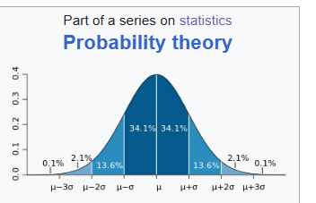

Parameter

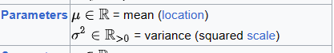

Support



PDF

U,{80ea751d-411f-41e6-937a-8f33c6e8ec10}{178},3.125,3.125

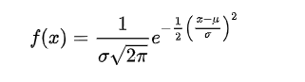

=

where

is the standard random value of $$x$$. That is,

$$z$$

= $$\frac{x−E\left[X\right]}{std\left(X\right)}$$

$$E\left[X\right]$$ refers the mean of random variable $$X$$.

$$std\left(X\right)$$ refers the standard deviation of random variable $$X$$.

CDF

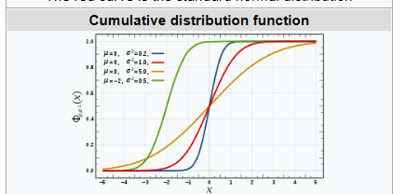

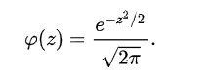

With the defi

$$CDF\left(x;E\left[X\right],std\left(X\right)\right)$$

= $$integral\left(PDF\left(t;E\left[X\right],std\left(X\right)\right)dt,t=−inf,t=\inf{}\right)$$

Expected Value



Variance



Skewness



Median



Mode



MGF



CF



MAD



Quantile



Ex. Kurtosis



General form

More information

Fisher’s information

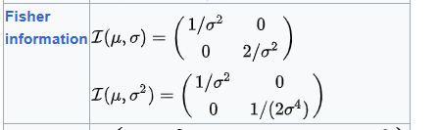

Kullback-Leiber divergence

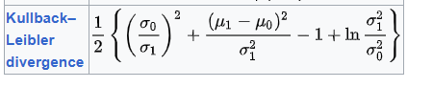

Ref

[Normal distribution - Wikipedia](https://en.wikipedia.org/wiki/Normal_distribution)